

|  |
| --- |
| University Health Leadership Development Academy |
| Participant Guide |
|  |
| Presented by Joycelyn Jones and Stephanie Whitehead |

|  |
| --- |
| Leading Others  4-16-2025 |

**Understanding the Landscape**

|  |  |
| --- | --- |
| **The Growing Gap** | **Burnout and Its Impact** |
| The healthcare workforce is facing significant challenges, with an increasing demand for professionals and a shrinking pool of qualified candidates. This gap is exacerbated by the aging workforce and the rising complexity of care delivery. | Burnout is rampant in healthcare, leading to high turnover, reduced patient satisfaction, and compromised quality of care. It is fueled by heavy workloads, administrative burdens, and emotional exhaustion. |

**Building a Foundation for Success: High-Performing Teams**

|  |  |
| --- | --- |
| **Defining High-Performing Teams** | **Benefits of High-Performing Teams** |
| High-performing healthcare teams share a common vision, communicate effectively, trust each other, embrace diverse perspectives, and are committed to achieving shared goals | These teams consistently deliver exceptional patient care, improve operational efficiency, foster innovation, and enhance staff satisfaction and retention. |

**Core Principles**

1. Communicate Effectively as a Leader
2. Create a Sense of Belonging
3. Enhance the Onboarding Process
4. Recognize Employees

NOTES:_______________________________________________________________________________________________________________________________________________________________________________________________________________________________________________________________________________________________________________________________________________________________________________________________________________________________________________________________________________________________________________________________________________________________________________________________________________________________________________________________________________________________________________________________________________________________________________________

**Effective Leadership Communication: The Cornerstone  **

|  |  |
| --- | --- |
| **Barriers to Effective Communication** | **Strategies for Improvement** |
| Healthcare settings are often characterized by complex information flows, time constraints, and hierarchical structures, which can create barriers to clear and timely communication. | Adopt active listening techniques, prioritize clear and concise messaging, leverage technology for efficient communication, and create regular channels for feedback. |

**Principle**

|  |  |
| --- | --- |
| **The Importance of Effective Communication From Leadership** | **NOTES:** |
| Promote collaboration  Ensure channels remain open and effective  Set clear expectations  Increase productivity  Maintain focus on goals and outcomes |  |

NOTES:_______________________________________________________________________________________________________________________________________________________________________________________________________________________________________________________________________________________________________________________________________________________________________________________________________________________________________________________________________________________________________________________________________________________________________________________________________________________________________________________________________________________________________________________________________________________________________________________

_______________________________________________________________________________________________________________________________________________________________________________________________________________________________________________________________

__________________________________________________________________________________________________________________________________________________________________________

_______________________________________________________________________________________________________________________________________________________________________________________________________________________________________________________________

**Principle**

**Barriers to Effective Communication**

|  |  |
| --- | --- |
| Lack of planning prior to communication  Lack of trust  Incorrect assumptions about listener   * Ignoring emotions | Inappropriate body language  Ignoring feedback  Lack of self-confidence  Aggression/coercion |

**Practice**

**Communication Tips**

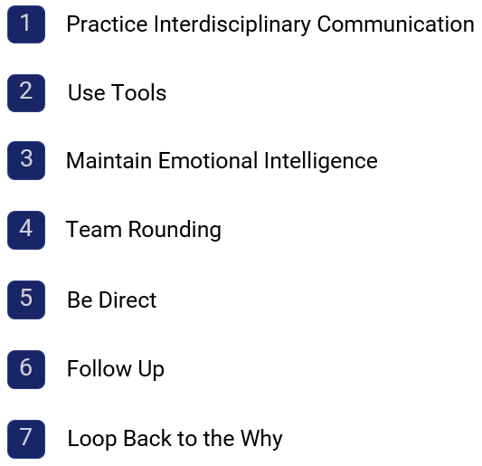

Consider all stakeholders

Include and inform all departments

When & How

Discuss pain points/consequences

InfoLINE

InfoHUDDLE

WebEx

Epic Secure Chat

Email

Difficult conversations

Be transparent & open

* It’s ok to say “I don’t know”
* Create trust

**Delivering Messages Effectively**

* Communicate the What, When, How
* The importance of the “Why”
* Express empathy

NOTES:_______________________________________________________________________________________________________________________________________________________________________________________________________________________________________________________________________________________________________________________________________________________________________________________________________________________________________________________________________________________________________________________________________________________________________________________________________________________________________________________________________________________________________________________________________________________________________________________

**Cultivating a Culture of Belonging: Psychological Safety**

|  |  |
| --- | --- |
| **What is Psychological Safety?** | **Fostering a Safe Space** |
| Psychological safety is the belief that one will not be punished or humiliated for speaking up with ideas, questions, concerns, or mistakes. | Promote open dialogue, encourage feedback and reflection, respect individual differences, and ensure equity and fairness in the workplace. |

**Safe Space**

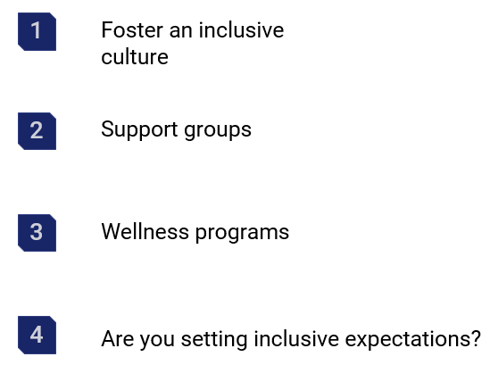

NOTES: ­­­­­­­­­­­­­­­_______________________________________

______________________________________________

______________________________________________  
______________________________________________  
______________________________________________  
______________________________________________  
______________________________________________

**Scenario**

A high dollar research experiment is underway.

As the project is underway, a junior scientist made a critical error that resulted in setbacks and delays for the entire study.

In the aftermath of the mistake, tensions flared, with some team members openly criticizing the junior scientist for their oversight. The atmosphere in the laboratory became strained, with lingering resentment and apprehension hindering collaboration and communication.

As the laboratory manager, you recognize the urgency of addressing the underlying issues and restoring psychological safety within the team. You understand that fostering a culture of trust, respect, and support is essential for not only nurturing creativity and innovation, but so that the study can continue with high-performance outcomes.

NOTES:_____________________________________________________________________________________________________________________________________________________________________________________________________________________________________________________________________________________________________________________________________________________________________________________________________________________________________________________________________________________________________________________________________________________________________________________________________________

**Practice**

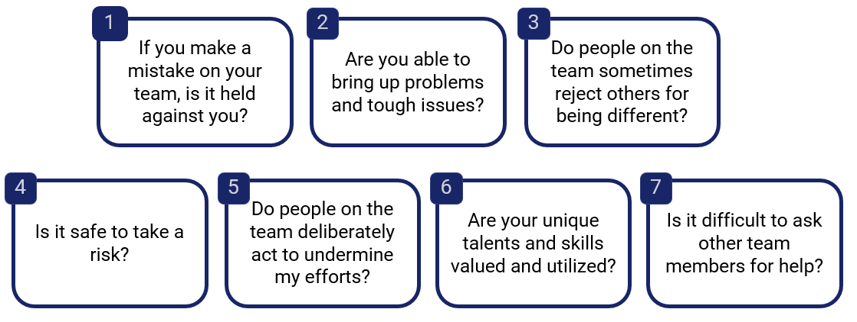

NOTES:_____________________________________________________________________________________________________________________________________________________________________________________________________________________________________________________________________________________________________________________________________________________________________________________________________________________________________________________________________________________________________________________________________________________________________________________________________________

______________________________________________________________________________________________________________________________________________________________________________________________________________________________________________________________________________________________________________________________________________________________________________________________________________________________________________________________________________________________________________________________

______________________________________________________________________________________________________________________________________________________________________________________________________________________________________________________________________________________________________________________________________________________________________________________________________________________________________________________________________________________________________________________________

**Onboarding for Success: Setting the Stage for Greatness**

|  |  |
| --- | --- |
| **Importance of Onboarding** | **Key Elements of Effective Onboarding** |
| A robust onboarding process is essential for integrating new employees, enhancing their confidence, and setting them up for success in their roles. | Provide clear expectations, facilitate team introductions, offer mentorship and support, and offer opportunities for professional development. |

**The Onboarding Experience is Critical**

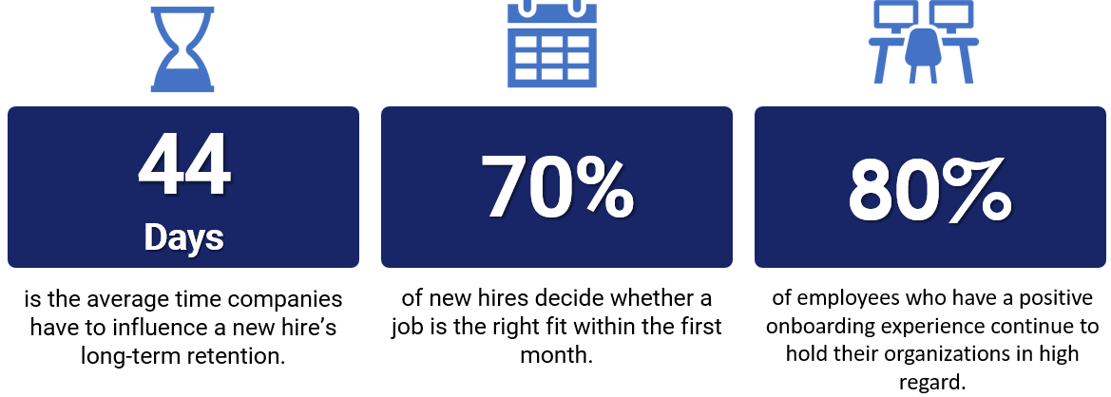

**Turnover**:

* On average, companies lose 18-22% of new hires during the first 6 months
* University Health Stats:
  + 2021 – 20.6%
  + 2022 – 19.0%
  + 2023 – 14.3%
  + 2024 – 13.7%

NOTES:_____________________________________________________________________________________________________________________________________________________________________________________________________________________________________________________________________________________________________________________________________________________________________________________________________________________________________________________________________________________________________________________________________________________________________________________________________________

_______________________________________________________________________________________________________________________________________________________________________________________________________________________________________________________________

**Initiate Greatness**

* There is an opportunity to create mission-infused moments that engage employees and foster belonging
* Motivate new employees to perform well and integrate into the culture of University Health

**Principle**

**Enhance Onboarding Process**

Which practices do you use to enhance the Onboarding Experience?

NOTES:_____________________________________________________________________________________________________________________________________________________________________________________________________________________________________________________________________________________________________________________________________________________________________________________________________________________________________________________________________________________________________________________________________________________________________________________________________________

_________________________________________________________________________________________________________________________________________________________________________________________________________________________________________________________________________________________________________________________________________________________________________________________________________________________________________

_________________________________________________________________________________________________________________________________________________________________________________________________________________________________________________________________________________________________________________________________________________________________________________________________________________________________________

**The Power of Recognition: Fueling Engagement and Retention**

|  |  |
| --- | --- |
| **The Impact of Recognition** | **Creating a Culture of Appreciation** |
| Studies show that employees who feel appreciated and valued are more likely to be engaged, productive, and loyal to their organization | Implement regular feedback systems, celebrate individual and team successes, and offer personalized recognition programs tailored to individual preferences |

**Recognition Isn’t Transactional**

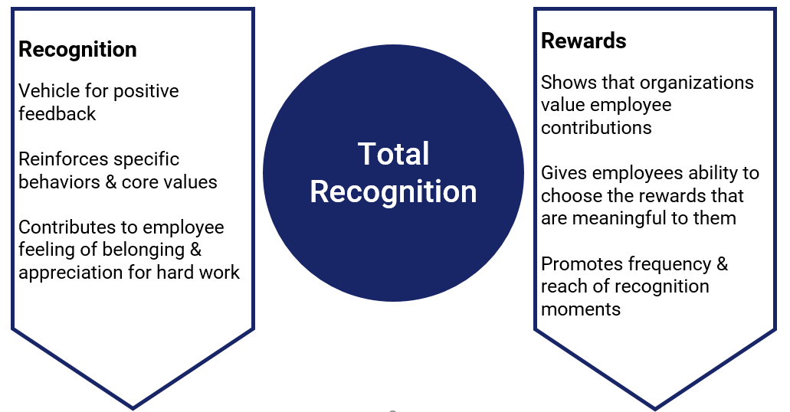

NOTES:_____________________________________________________________________________________________________________________________________________________________________________________________________________________________________________________________________________________________________________________________________________________________________________________________________________________________________________________________________________________________________________________________________________________________________________________________________________

_________________________________________________________________________________________________________________________________________________________________________________________________________________________________________________________________________________________________________________________________________________________________________________________________________________________________________

**The ROI-Generating Power of Personal Recognition**

- Lowest voluntary turnover when employees are recognized for good work *and* personal milestones

- Employees who received recognition for a life event vs. those who did not:

2x more likely to recognize others

1.5x more likely to be recognized

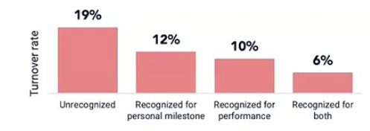

**The Value of Rewards**

**Programs that consist solely of e-thanks do more harm than good**: Workhuman conducted a turnover analysis across 34 customers, totaling more than 67K workers

* Workers who received 5+ rewards, with at least one having monetary value, were **4x more likely** **to stay** with their organization
* A worker with 5+ e-thanks awards became at least **3x more likely to leave** the organization than a worker who received no recognition at all

**Practice**

**Employee Recognition**

* Implement Recognition Programs
* Celebrate Achievements
* Appreciate Diverse Backgrounds

NOTES:_____________________________________________________________________________________________________________________________________________________________________________________________________________________________________________________________________________________________________________________________________________________________________________________________________________________________________________________________________________________________________________________________________________________________________________________________________________

**Activity: Feed Forward**

**Brainstorming Activity for Rewards and Recognition**

1. Partner up with 1 other person in the room (don’t forget to introduce yourself!)
2. Share an issue you’re having in the area of rewards and recognition that you’d like to work on
   1. Individualization
   2. Consistency
   3. Time
3. Your partner will provide an idea on how to solve the problem
4. Write down their idea and thank them
   1. Do not argue/disagree – this is about everyone getting lots of ideas, not debate!
5. Reverse it! Let your partner share their issue and give them an idea
6. Find another person and keep going until you have a list of ideas

NOTES:_____________________________________________________________________________________________________________________________________________________________________________________________________________________________________________________________________________________________________________________________________________________________________________________________________________________________________________________________________________________________________________________________________________________________________________________________________________

_________________________________________________________________________________________________________________________________________________________________________________________________________________________________________________________________________________________________________________________________________________________________________________________________________________________________________

_________________________________________________________________________________________________________________________________________________________________________________________________________________________________________________________________________________________________________________________________________________________________________________________________________________________________________

_________________________________________________________________________________________________________________________________________________________________________________________________________________________________________________________________________________________________________________________________________________________________________________________________________________________________________

_________________________________________________________________________________________________________________________________________________________________________________________________________________________________________________________________________________________________________________________________________________________________________________________________________________________________________

_________________________________________________________________________________________________________________________________________________________________________________________________________________________________________________________________________________________________________________________________________________________________________________________________________________________________________

_________________________________________________________________________________________________________________________________________________________________________________________________________________________________________________________________________________________________________________________________________________________________________________________________________________________________________

_________________________________________________________________________________________________________________________________________________________________________________________________________________________________________________________________________________________________________________________________________________________________________________________________________________________________________

_________________________________________________________________________________________________________________________________________________________________________________________________________________________________________________________________________________________________________________________________________________________________________________________________________________________________________

**Contacts**

**Joycelyn Jones, MSHRM, SHRM-CP**

Employee Experience Manager

Center for Learning Excellence

210-644-6037

[Joycelyn.Jones@uhtx.com](mailto:Joycelyn.Jones@uhtx.com)

**Stephanie Whitehead**

Executive Director of Pathology Services

Lab Administration

210-358-2760

[Stephanie.Whitehead@uhtx.com](mailto:Stephanie.Whitehead@uhtx.com)